06.05.2024
PROGRAMMING LANGUAGES PROJECT
LEXICAL ANALYZER

NAME : BURAK KOCABAŞ
ID: 05220000303

NAME : YUSUF ENES SÖZERİ
ID : 05220000294

Code example containing all types of Identifiers, Integer constants, Operators, Brackets, String constants, Keywords, End of line, Comma, Comments and no Error conditions

INPUT:
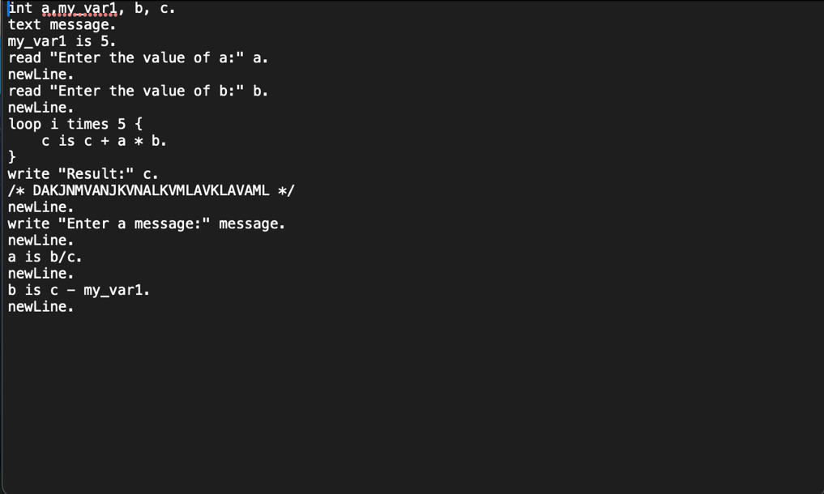

ITS OUTPUT : 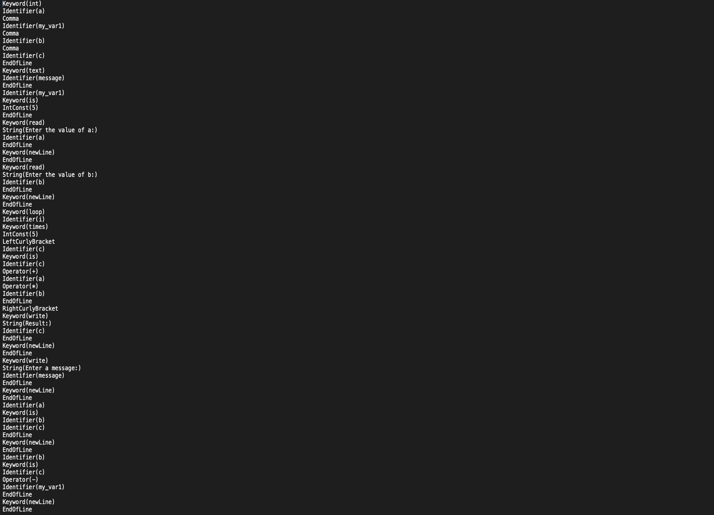
ERROR CASES

1-Identifier Maximum Size Exceed:
Input:
Output
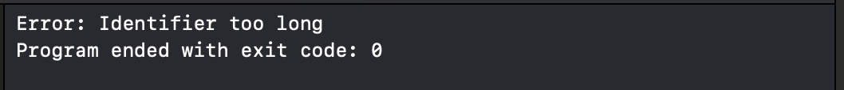

2-IntegerConst Maximum Size Exceed:
Input :
Output:
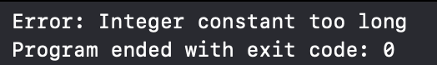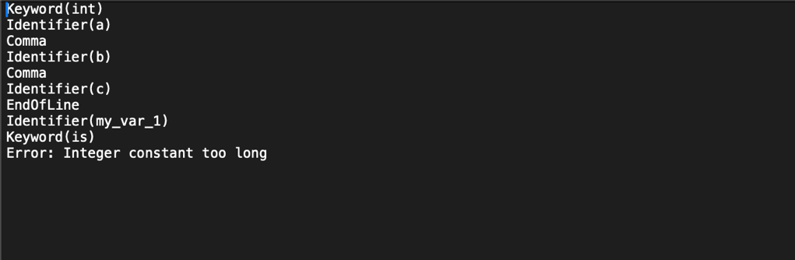

3-Negative Integer Usage:
Input:
Output:
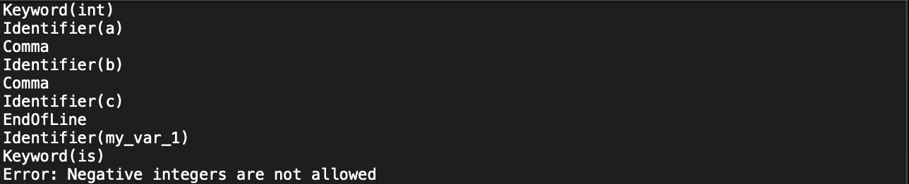
4-String Maximum Size Exceed:
Input :
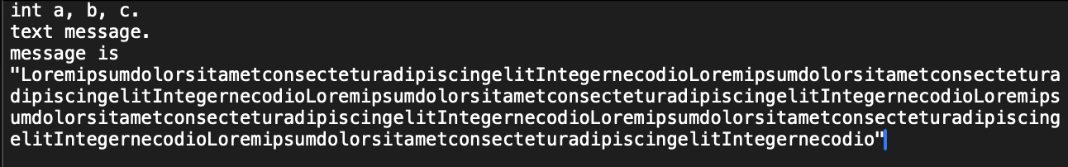
Output :
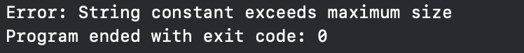
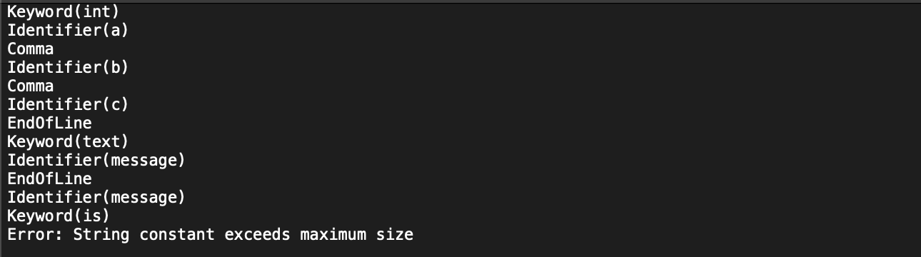

5- Double Quetes In String Constant
Input:
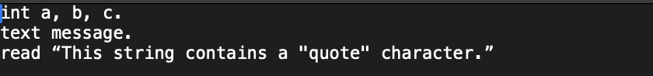
Output:
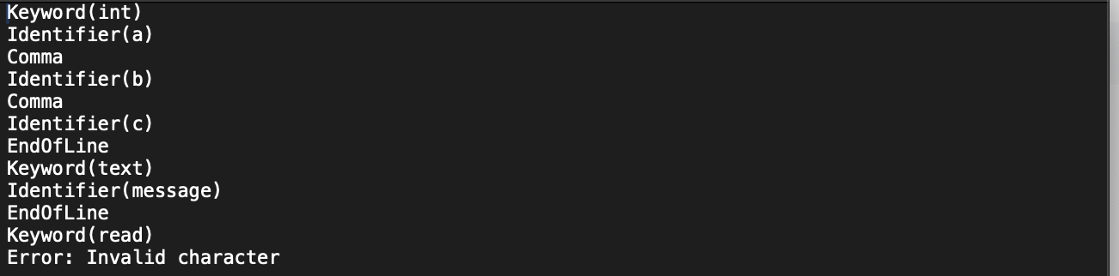

6-End Of Comment
Input:
Output:
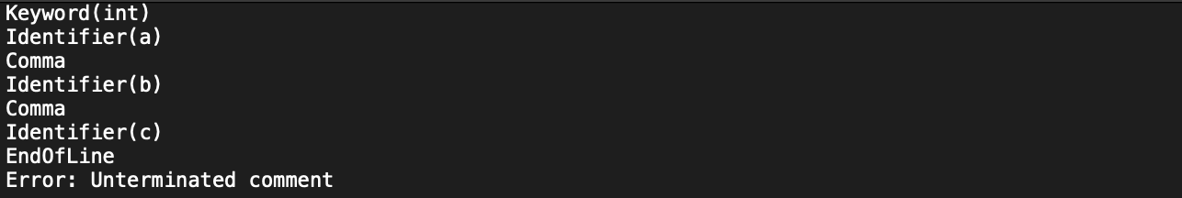
7-Unterminated String at the End Of File
Input:
Output:
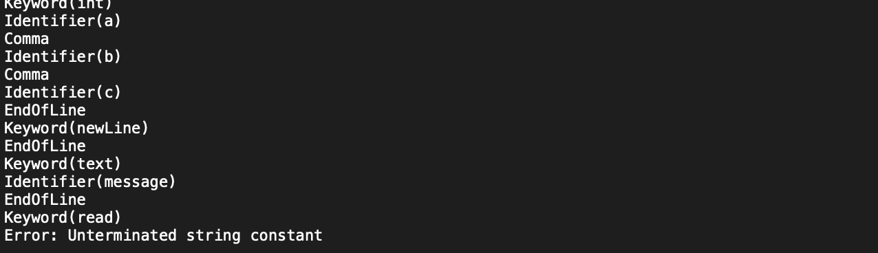

8- Invalid Character
Input:

Output: